The Importance of Being Ernest , Act III, Reading Questions
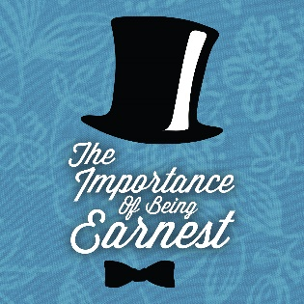
1) ACT III takes place
□ in the living room of the Manor House.
□ in the garden of the Manor House.
□ in the drawing room of the Manor House.
- Why does Cecily keep a diary ?
□To tell all the events of her life.
□To remember her lessons.
□To record her thoughths and impressions.
- What did she write in her diary three months before ?
Her ....................................... with ........................ though she never met him.
- Cecily thinks that she could only love a man called ................ (like ...........................).

- ..................................... arrives when Ernest leaves to speak to Dr .......................... .

- What does Gwendolen think of Jack’s ward ?
..............................................................................................................................................
- What is the cause of the confusion between Gwendolen and Cecily ?
........................................................................................................................................................................................................................................................................................................
- According to Gwendolen what is unfashionable ?
□ the countryside
□ sugar and cake at afternoon tea
□ tea-cakes at afternoon tea

- What do Algernon and Jack do after the women leave the room ?
□The two men argue while eating muffins.
□The two men have a fight while eating cucumber sandwiches.
□The two men have tea while eating scones.

