TAKE A STAND p. 90 and 91

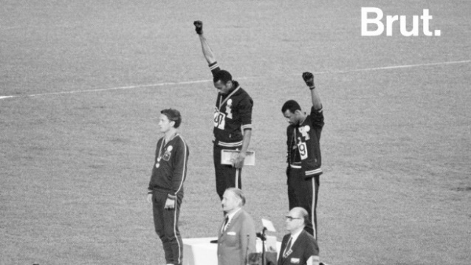
This famous picture was taken in 1968 during the Olympic Games in Mexico City. There are three men on the podium after the 200 m race: the American Tommie Smith, the Australian Peter Norman and another American John Carlos. These athletes took a stand to protest against the civil rights injustices in the U.S.A.
When the American national anthem began, they raised their fists in a Black Power salute and bowed their heads. The clenched fist is a reference to the Black Power movement. They wore black socks to denounce black poverty. The Human Rights Badge is a way to fight against racism. Tommie Smith and John Carlos had to face terrible consequences: the crowd started jeering, they were blacklisted from the sport. Later, they were tracked by the FBI and they even received death threats.
Peter Norman was also heavily criticised upon his return to Australia. He was suspended and never returned to the sport. The Australian government didn’t apologize for the treatment that Norman received until 2012, 6 years after his death.

