Answer sheet | MID Anglais-SI | Quick programming learn  Part 1 - Blockly

Question 1

VIDEO HOUR OF CODE INTRODUCTION

Who is the first person interviewed on the video?
Bill Gates
What class was he in when he first learnt to program?
8th grade
What is the name of the next man talking in the video?
Marc Zuckerberg
What is computer science?
Computer sciences is how a computer works and how it thinks
What is programming according to Drew?
He created DropBox
What kind of programming “language” will be used in this program?
Blocs Language
What is the purpose of programming in this video?
Help the angry bird to catch the evil pig
What is the workspace for?
You put blocks there in the order to make your program
How do you “write” a command?
You drop a block in the workspace
What do you do when you want to delete a block?
You drop it in the trashcan
VIDEO HOUR OF CODE (MARK)

What are computers really good at?
What is a billion of times?
VIDEO HOUR OF CODE (CHRIS)

Who is Chris?

How do you get good at doing something?

What did he do when practicing his sport? Why do you think he did that?

VIDEO IF ELSE BLOCK
What is an if-else statement?
With this block you can make a condition and a solution
What is the difference with the if-block?
You can only make a condition

In the first lesson five programming structures where introduced: linear structure, repeat until structure, loop forever, repeat structure, if and if/else statement.

Question 2
Write, next to each picture, the name of the structure/structures used in the code.

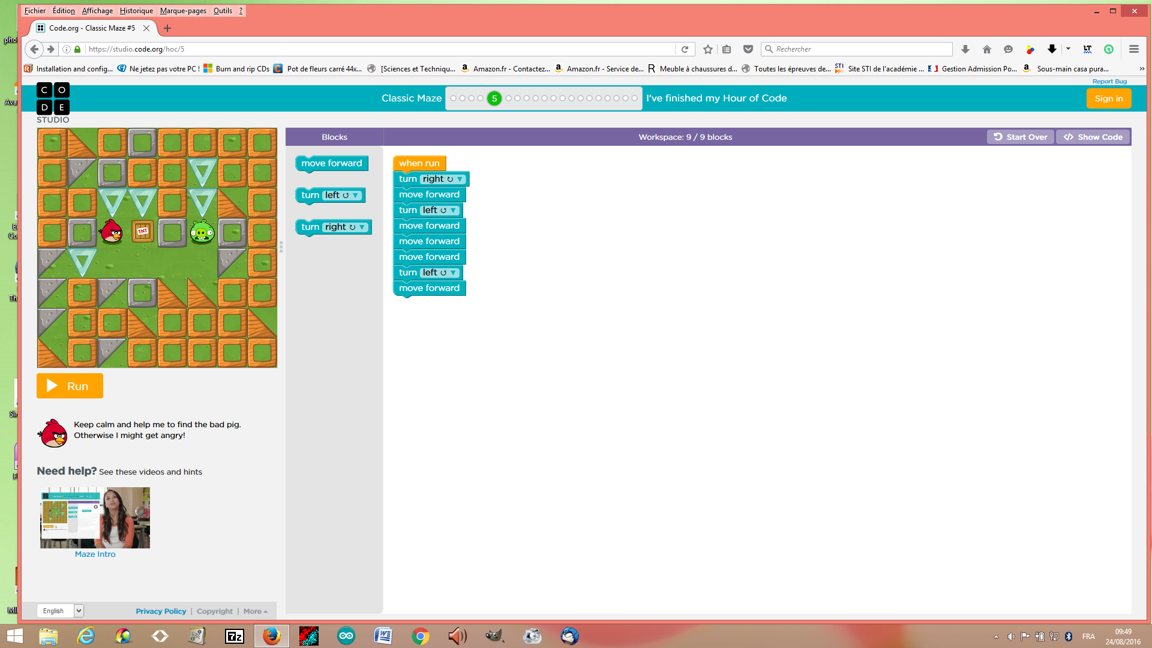

Name of the structure: Move forward, turn left and turn right

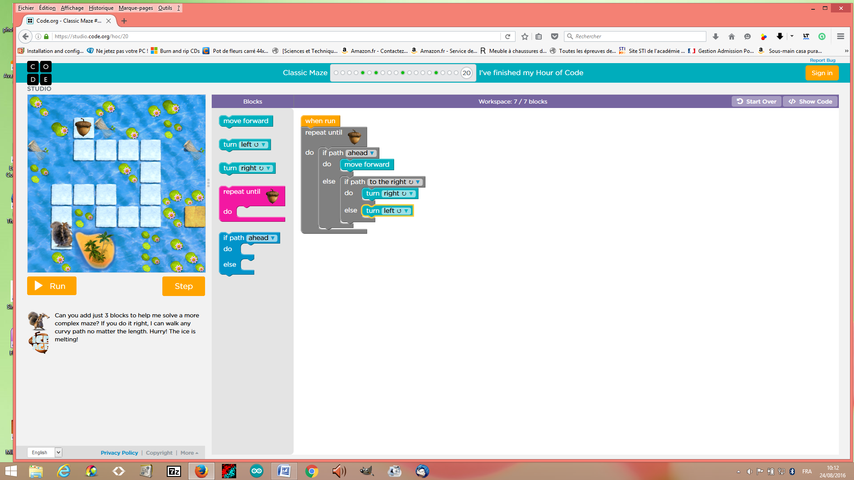

Name of the structure(s): repaet until, in path ahead, move forward, in path to the right turn right and turn left

Explain the if- block and the if/else block : If can't turn right you will turn left

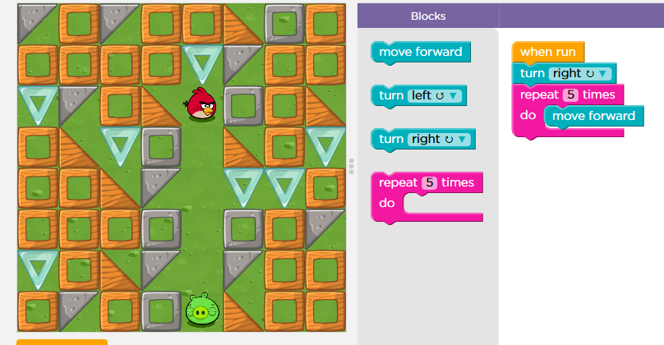
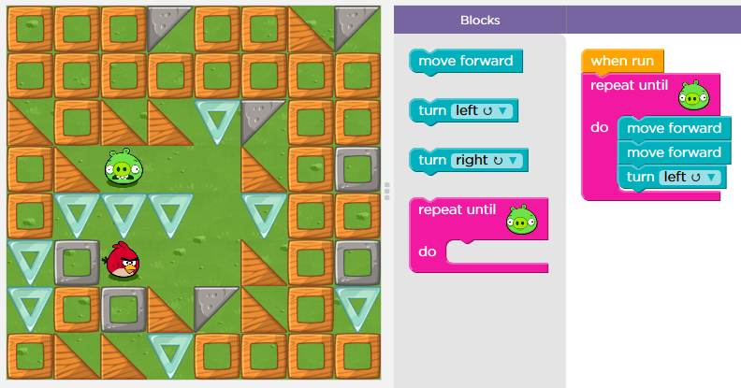

Name of the structure: repeat 5 times,
turn right and move forward
Name of the structure: repeat until, move
forward and turn left

You can use two different ways to repeat the same command. Explain both ways:

You can use the command “repeat … times” or “repeat until bird touch the evil pig”. First command repeat only a number. And the seconde command repaet the action until a definite things.

Question 3

Explain what the zombie will do to get to the flower.
What statement can be used in your code?

The zombie have to repeat until he touch the flower this command : turn right, move forward, turn left, move forward.

Question 4

Click the file “blockly_crossword.htm” and complete the crossword.

Write down your score: ...................

Save your answer sheet as “Test_L1_your name” in your BLOG.

