Answer sheet | MID Anglais-SI | Quick programming learn  Part 1 - Blockly

Question 1

VIDEO 1 HOUR OF CODE: INTRODUCTION

Who is the first person interviewed on the video?
He's Bill GATE, the microsoft's founder.

What class was he in when he first learnt to program?
He was in 8th grade.

What is the name of the next man talking in the video?
He's Marck Zuckerberg, the facebook's founder.

What is computer science?
It’s the learning of “how a computer works and how does he think?”

What is programming according to Drew?
He thinks programming give us a superpower.

What kind of programming “language” will be used in this program?
C++

What is the purpose of programming in this video?
The purpose of programming in this video is to learn basic codes.

What is the workspace for?
We use blocky.

How do you “write” a command?
We don't write commands, we move blocks to use the effect who's wrote in it.

What do you do when you want to delete a block?
He move it to the recycle bin.

VIDEO 2 HOUR OF CODE: MARK

What are computers really good at?
The computers are good at repeating commands.

What is a billion of times? Write answer in French
1 billion times = 1 milliards de fois

VIDEO 3 HOUR OF CODE: CHRIS

Who is Chris?
He's a baskeball player.

How do you get good at doing something?
To get good at doing something we need to do it many times.

What did he do when practicing his sport? Why do you think he did that?
He did the same move until he did the same move 10 times in row.

VIDEO 4 IF ELSE BLOCK

What is an if-else statement?
That's a condition for an action: if that thing appear, then we do that. Else, if that thing doesn’t appear, then we do this.

What is the difference with the if-block?
We can do an order if the “if” command have a wrong answer.

In the first lesson five programming structures where introduced: linear structure, repeat until structure, loop forever, repeat structure, if and if/else statement.

Question 2
Write, next to each picture, the name of the structure/structures used in the code.

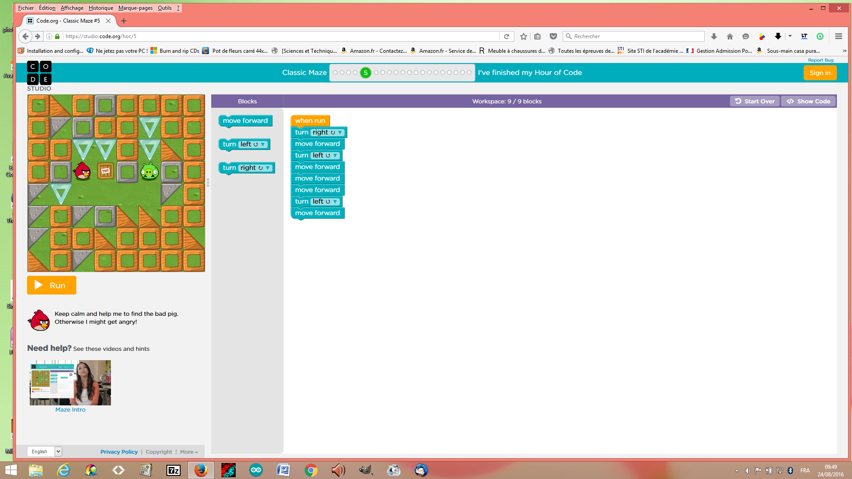

Name of the structure: ....

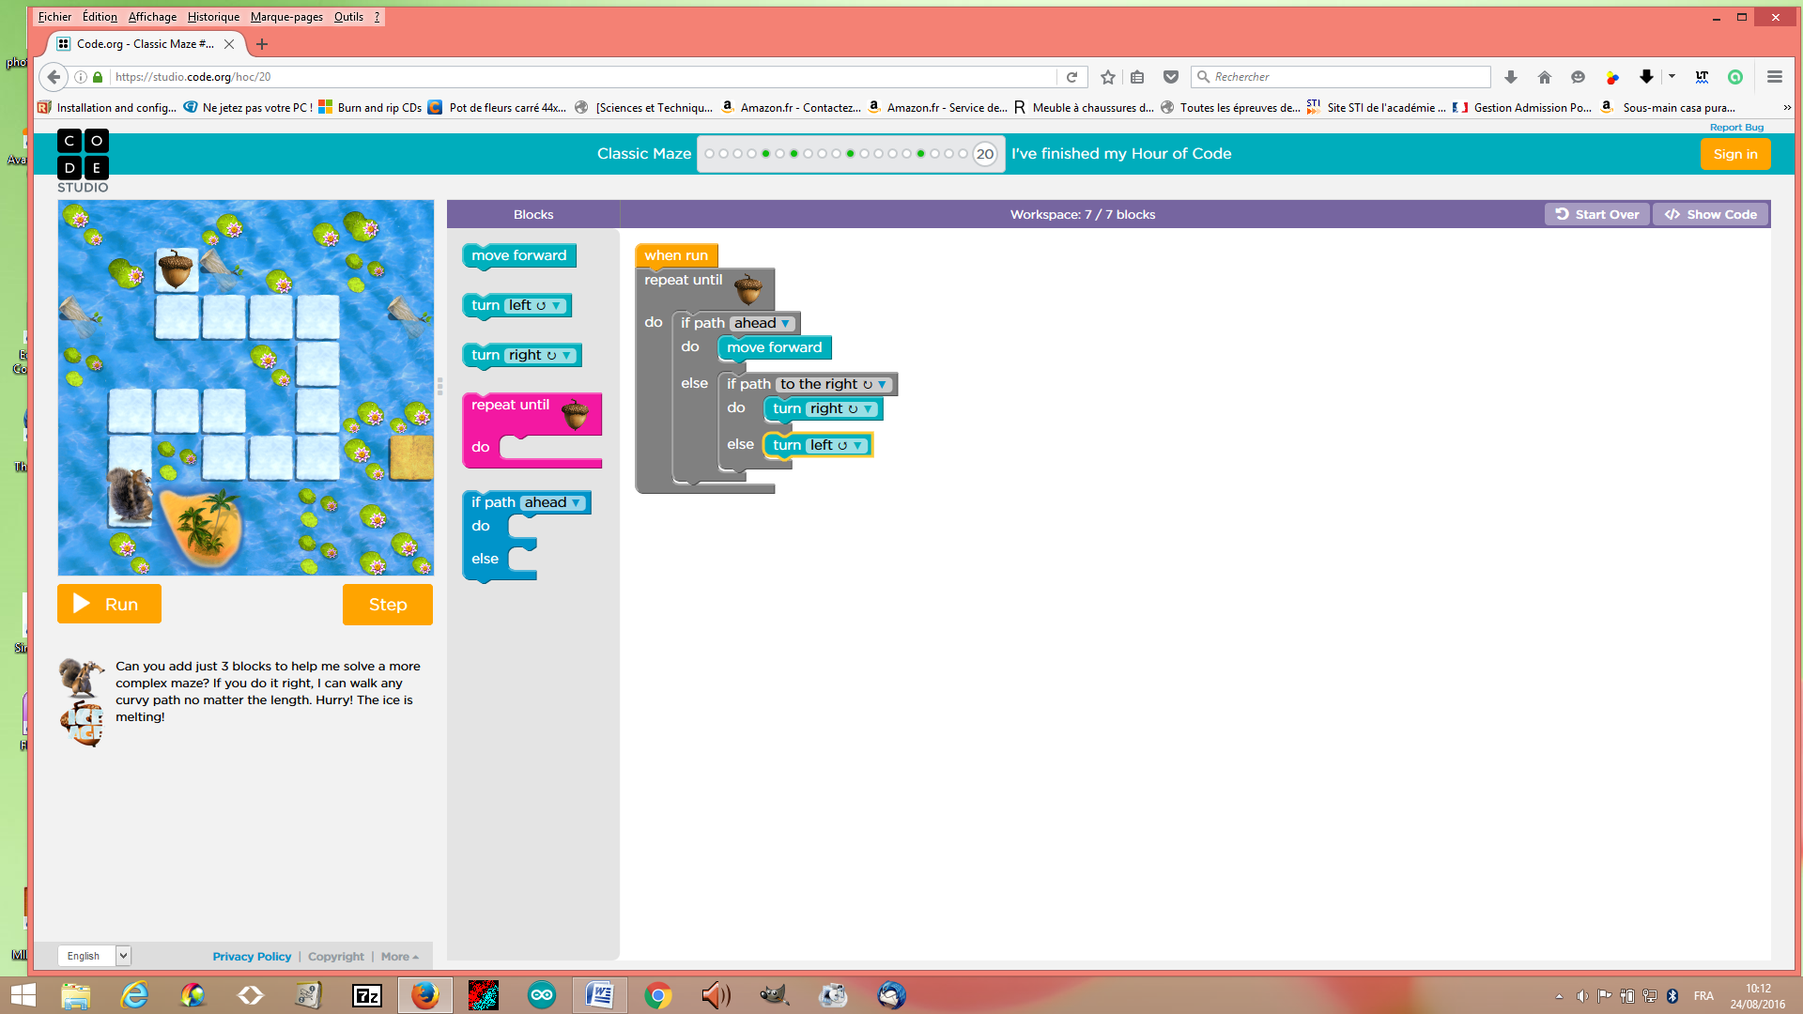

Name of the structure(s): …

Explain the if- block and the if/else block: ...

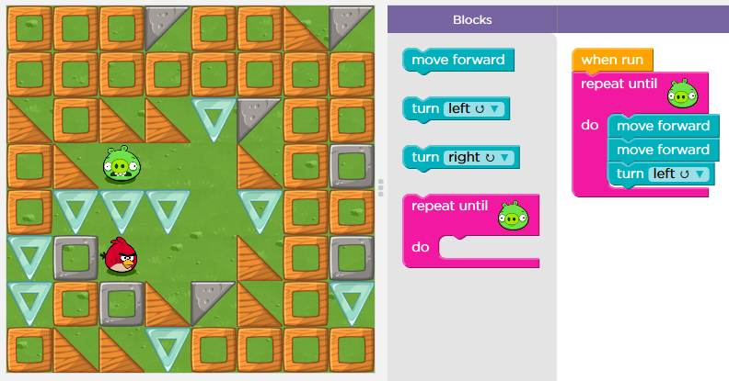
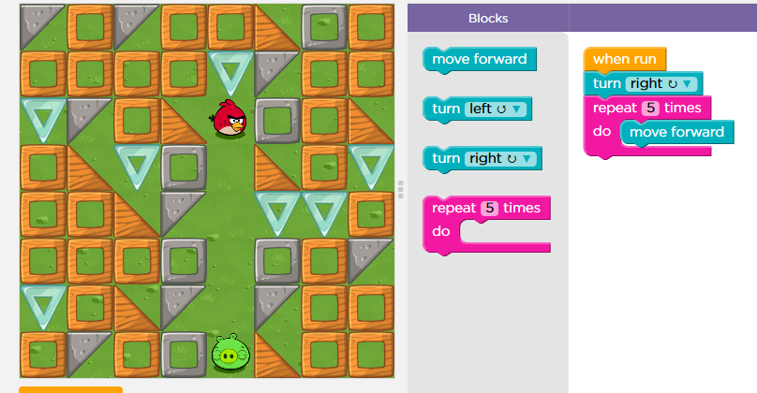

Name of the structure: Name of the structure: repeat until the bird meet
repeat with a definite number of time a movement a green pig

You can use two different ways to repeat the same command. Explain both ways:
You can repeat until an impediment or you can order to repeat a defined number of time

Question 3

Explain what the zombie will do to get to the flower.
What statement can be used in your code?
Repeat until

Question 4

Click the file “blockly_crossword.htm” and complete the crossword.

Write down your score: 100%

Save your answer sheet as “Test_L1_your name” in your groupe folder in LOL.

(Dossier MID_GR...).

