Happy families 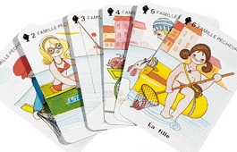
Shuffle the cards Deal the cards
Who starts? Now, it’s your turn.
Member of the family

Colour

HAVE YOU GOT THE please ?

Ex : Have you got the blue father please ?
Yes , I have. No, I haven’t / have not.
Here you are. Pick up a card.

I have got a family !

