Atelier SPORTS REPORTER
****************

Do you like…?
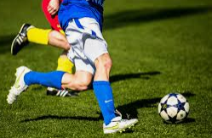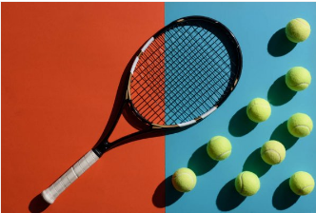

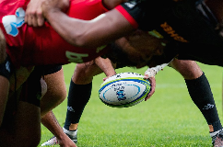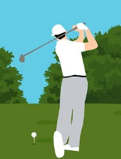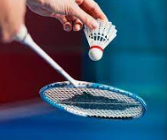

I like I don’t like

Sports reporter
My name is …………………………………
Name:……………….
Name:……………….
Name:……………….
Name:……………….
Name:……………….
Name:……………….

Sports reporter
My name is …………………………………
Name:……………….
Name:……………….
Name:……………….
Name:……………….
Name:……………….
Name:……………….

Sports reporter
My name is …………………………………
Name:……………….
Name:……………….
Name:……………….
Name:……………….
Name:……………….
Name:……………….

Sports reporter
My name is …………………………………
Name:……………….
Name:……………….
Name:……………….
Name:……………….
Name:……………….
Name:……………….

Sports reporter
My name is …………………………………
Name:……………….
Name:……………….
Name:……………….
Name:……………….
Name:……………….
Name:……………….

Sports reporter
My name is …………………………………
Name:……………….
Name:……………….
Name:……………….
Name:……………….
Name:……………….
Name:……………….

