Answer sheet | MID Anglais-SI | Quick programming learn  Part 1 - Blockly

Question 1

VIDEO HOUR OF CODE INTRODUCTION

Who is the first person interviewed on the video?

The first person is Elena

What class was he in when he first learnt to program?

She was in 8th grades.

What is the name of the next man talking in the video?

The next man is Mark Zuckerberg

What is computer science?

Computer sciences is learning how a computer works

What is programming according to Drew?

Drew think programming is a superpower

What kind of programming “language” will be used in this program?

We used blackly

What is the purpose of programming in this video?

What is the workspace for?

The workspace is where we build our program

How do you “write” a command?

You move blocks.

What do you do when you want to delete a block?

You drag the block to the trashcan.

VIDEO HOUR OF CODE (MARK)

What are computers really good at?

Computers are really good to repeating commands

What is a billion of times?

A billion of time is “des milliards de fois” in French.

VIDEO HOUR OF CODE (CHRIS)

Who is Chris?

Chris is a basketball player

How do you get good at doing something?

To be good you need to repeat many times

What did he do when practicing his sport?

He repeats his free throws many times

Why do you think he did that?

VIDEO IF ELSE BLOCK
What is an if-else statement?

What is the difference with the if-block?

In the first lesson five programming structures where introduced: linear structure, repeat until structure, loop forever, repeat structure, if and if/else statement.

Question 2
Write, next to each picture, the name of the structure/structures used in the code.

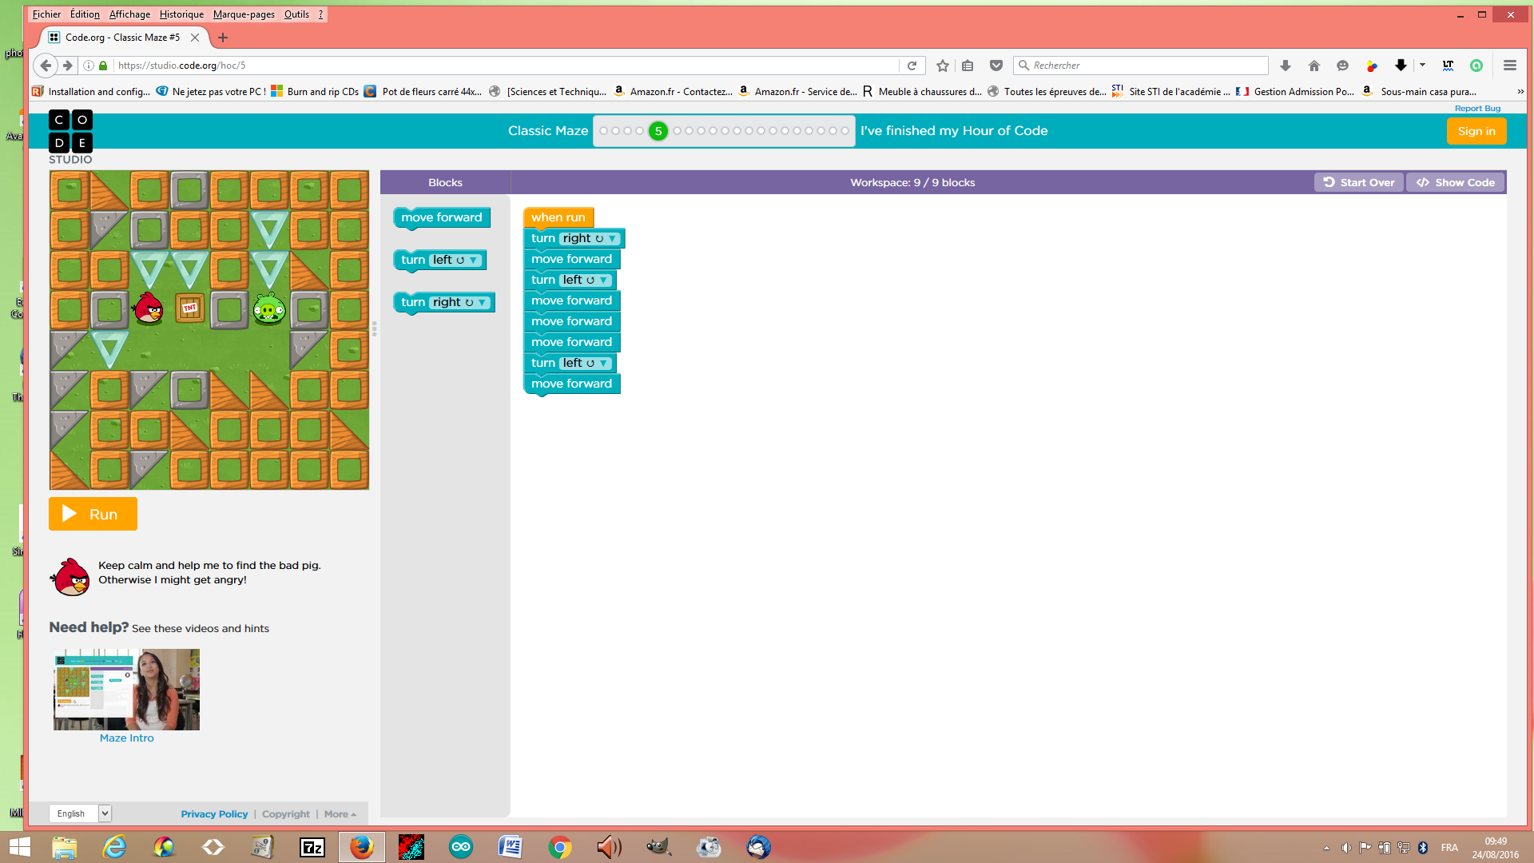

Name of the structure: linear structure

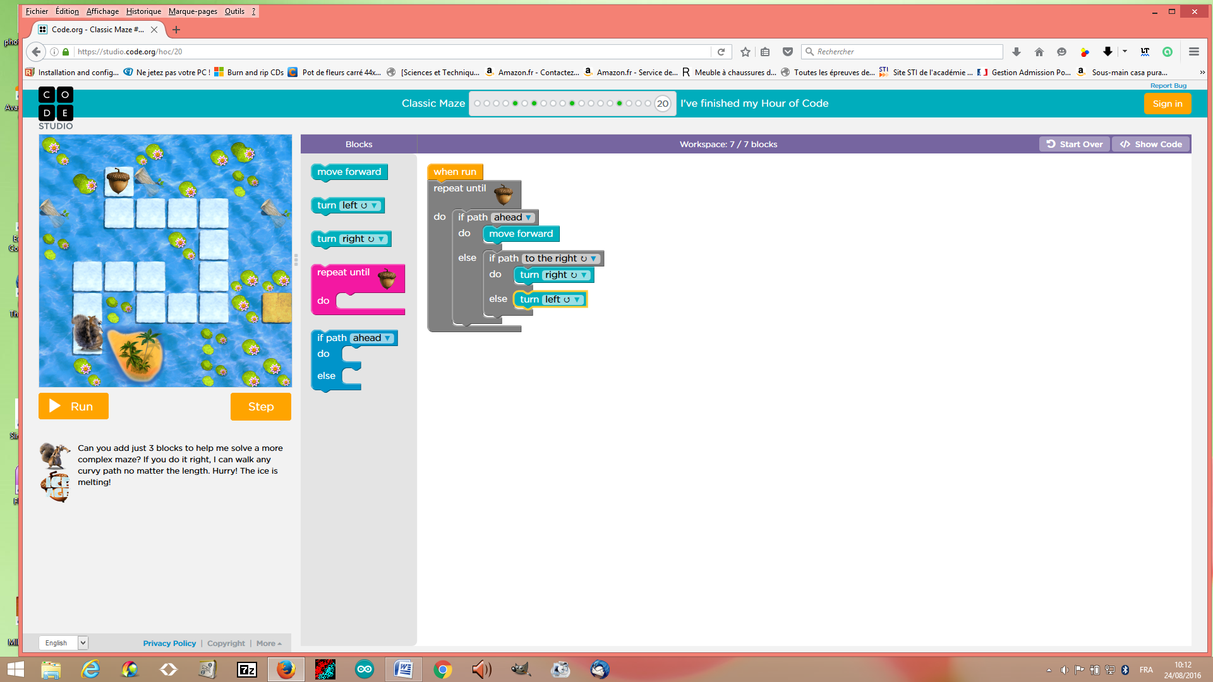

Name of the structure(s): if and if/else statements

Explain the if- block and the if/else block:

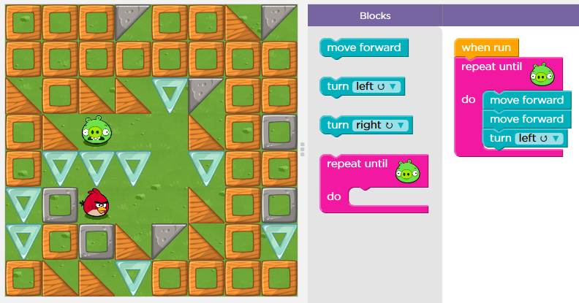
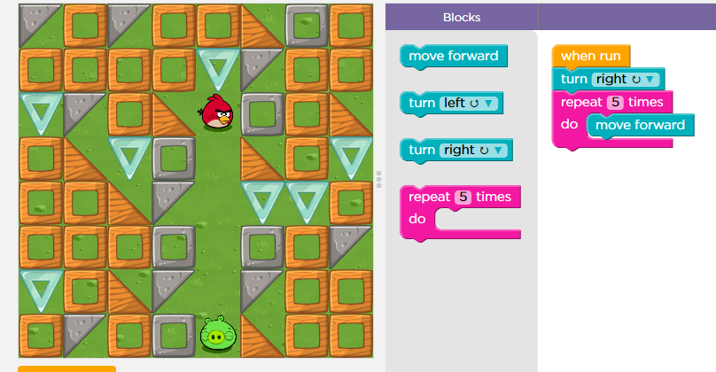

Name of the structure: repeat structure
Name of the structure: repeat until structure

You can use two different ways to repeat the same command. Explain both ways:

To repeat the same command you can use the repeat structure or the loop forever

Question 3

Explain what the zombie will do to get to the flower.
What statement can be used in your code?

The zombie need to turn right, move forward, turn left, move forward and repeat until the flower. We use the repeat until block

Question 4

Click the file “blockly_crossword.htm” and complete the crossword.

Write down your score: 88 %

Save your answer sheet as “Test_L1_your name” in your BLOG.

