Answer sheet | MID Anglais-SI | Quick programming learn  Part 1 - Blockly

Question 1

VIDEO HOUR OF CODE INTRODUCTION

Who is the first person interviewed on the video?
Bill gates
What class was he in when he first learnt to program?
Ninth grade
What is the name of the next man talking in the video?
Elena, she created clothia.com
What is computer science?
Learning how a computer works and how it thinks

What is programming according to Drew ?
The closest thing we have to superpower
What kind of programming “language” will be used in this program?
blockly
What is the purpose of programming in this video?
Get the angry bird to the evil pig
What is the workspace for?
For assambling commands
How do you “write” a command?
Youy drag and drop the command block to the right place
What do you do when you want to delete a block?
You click the delet button

VIDEO HOUR OF CODE (MARK)

What are computers really good at?
Doing the same thing a lot of times (billions and billions and billions)
What is a billion of times?
that’s more than a million times

VIDEO HOUR OF CODE (CHRIS)

Who is Chris?
All star nba player
How do you get good at doing something?
Practicing and repeating the same thing over and over again
What did he do when practicing his sport? Why do you think he did that?
He tried over and over again to make ten free throws in a row
VIDEO IF ELSE BLOCK
What is an if-else statement?
Depending on if something happens or not, the 1 or 2 solution will happen
What is the difference with the if-block?
There is a second solution

In the first lesson five programming structures where introduced: linear structure, repeat until structure, loop forever, repeat structure, if and if/else statement.

Question 2
Write, next to each picture, the name of the structure/structures used in the code.

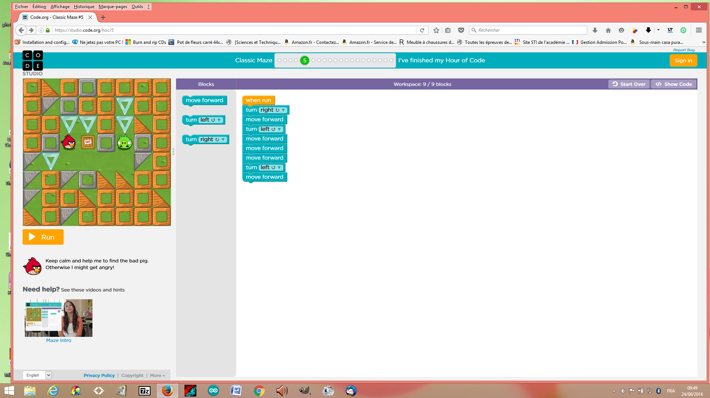

Name of the structure: ....

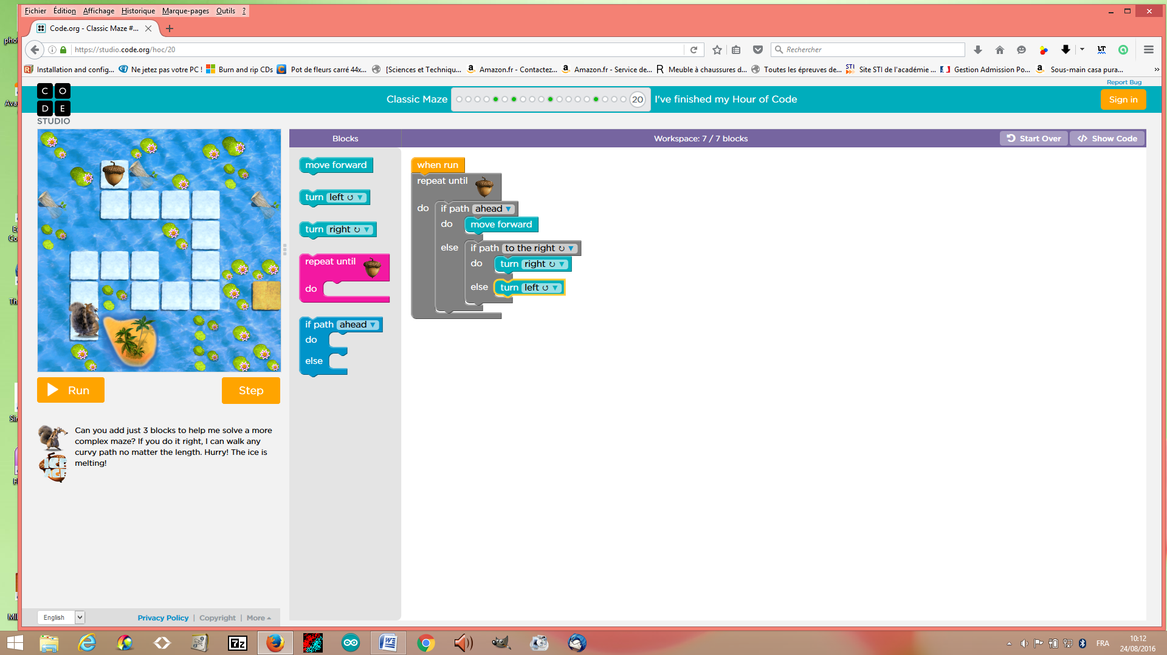

Name of the structure(s): if else

Explain the if- block and the if/else block:

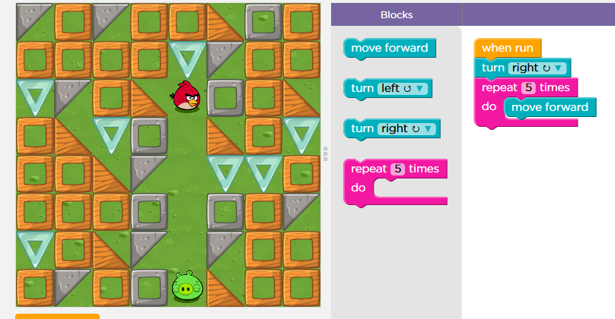
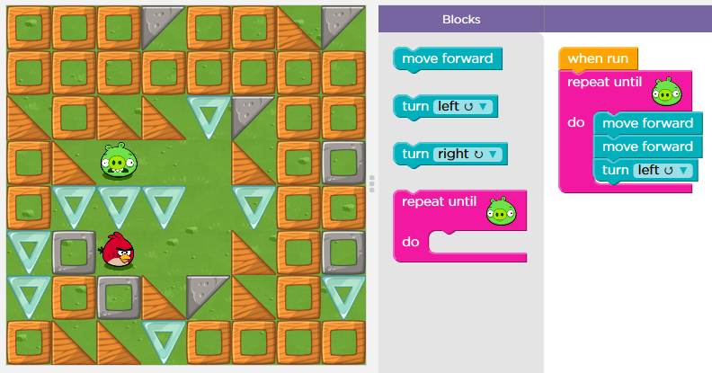

Name of the structure: ....
Name of the structure: ....

You can use two different ways to repeat the same command. Explain both ways:

Question 3

Explain what the zombie will do to get to the flower.
What statement can be used in your code?

...............

Question 4

Click the file “blockly_crossword.htm” and complete the crossword.

Write down your score: …................

Save your answer sheet as “Test_L1_your name” in your BLOG.

