Answer sheet | MID Anglais-SI | Quick programming learn  Part 1 - Blockly

Question 1

VIDEO 1 HOUR OF CODE: INTRODUCTION

Who is the first person interviewed on the video? The first person who interviewed is Bill Gates

What class was he in when he first learnt to program? Ihe learn his first program at 8th class.

What is the name of the next man talking in the video? The next man who talking in the vidéo is Marc zuckerberg, he is founder of Apple.

What is computer science? The computer science is a programator who create games, applications...

What is programming according to Drew? The Programming is Blockly.

What kind of programming “language” will be used in this program? This programs use blocs

What is the purpose of programming in this video? You can deplace a person.

What is the workspace for? It’s for executate programs.

How do you “write” a command? You need to place a bloc in front of an other bloc an click.

What do you do when you want to delete a block? I put the bloc in the bin.

VIDEO 2 HOUR OF CODE: MARK

What are computers really good at? The computers are really good to repeat codes.

What is a billion of times? Write answer in French. C’est un milliards.

VIDEO 3 HOUR OF CODE: CHRIS

Who is Chris? Chris is an informatic etudiant.

How do you get good at doing something? You need to use lessier blocs for deplace your person as good as a point.

What did he do when practicing his sport? Why do you think he did that? When you do sports, you repeat as good as the perfection one movement for example.

VIDEO 4 IF ELSE BLOCK

What is an if-else statement? If is for a condition and else it’s if if is not use.

What is the difference with the if-block? The difference is if is a condition and else is if don’t work.

In the first lesson five programming structures where introduced: linear structure, repeat until structure, loop forever, repeat structure, if and if/else statement.

Question 2
Write, next to each picture, the name of the structure/structures used in the code.

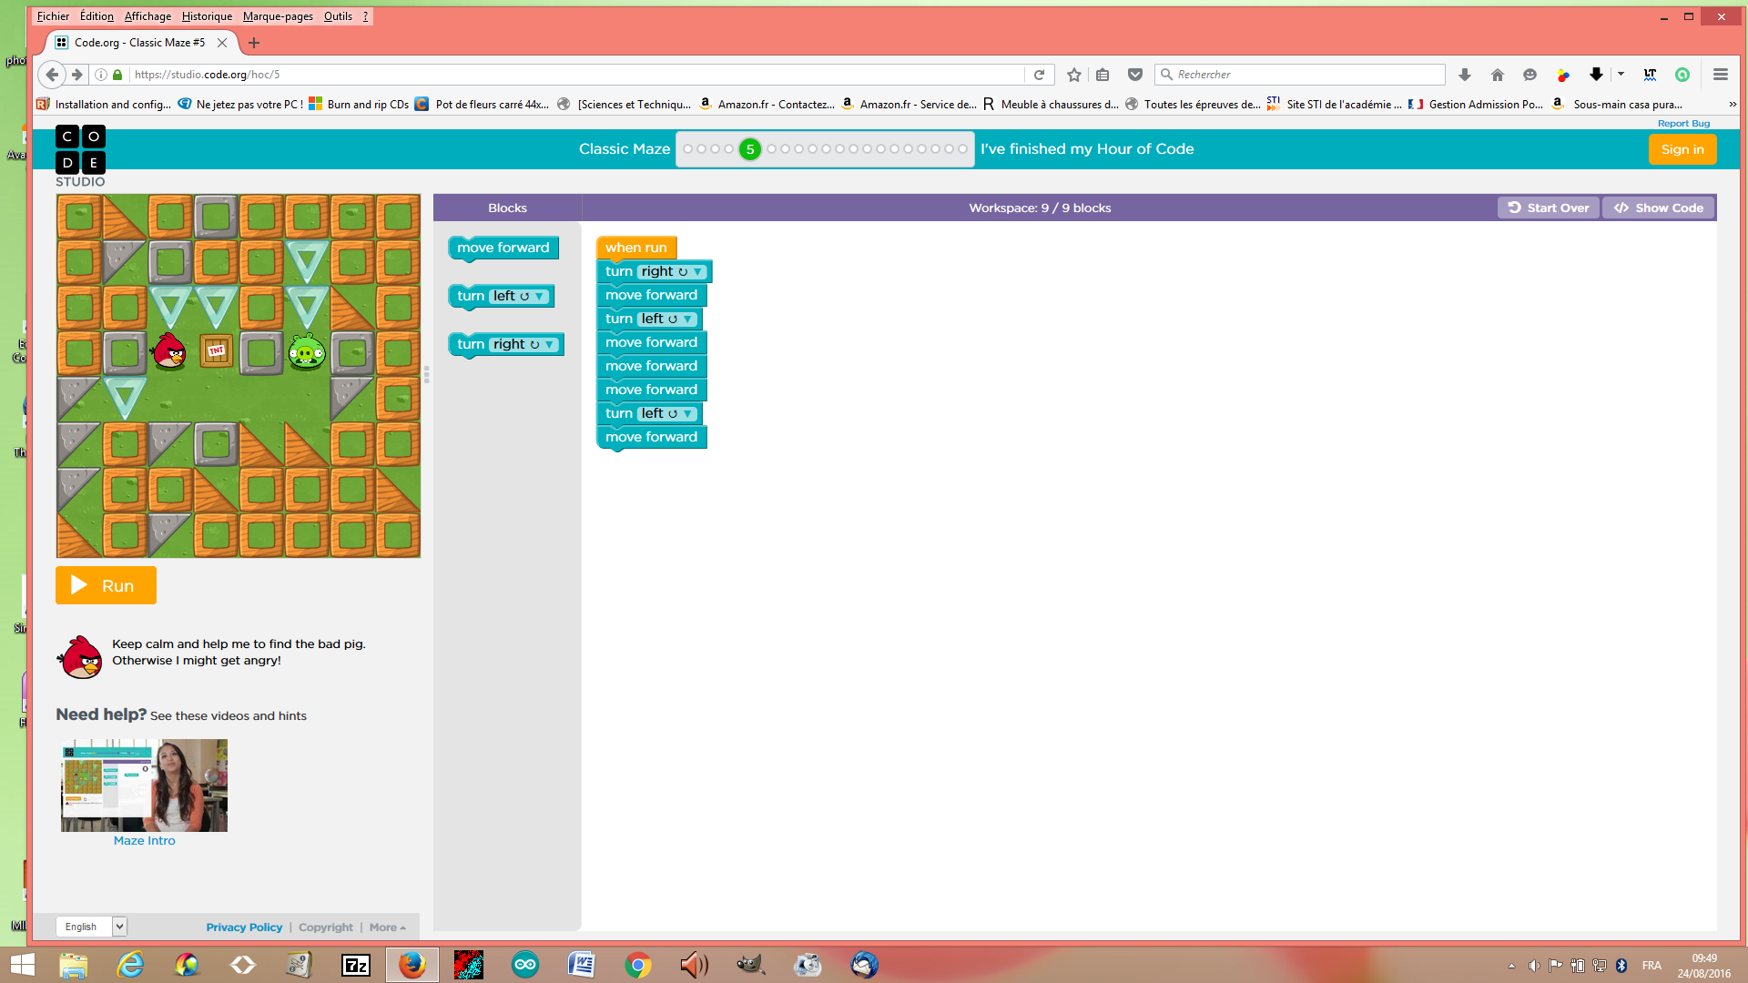

Name of the structure: ....Linear structure

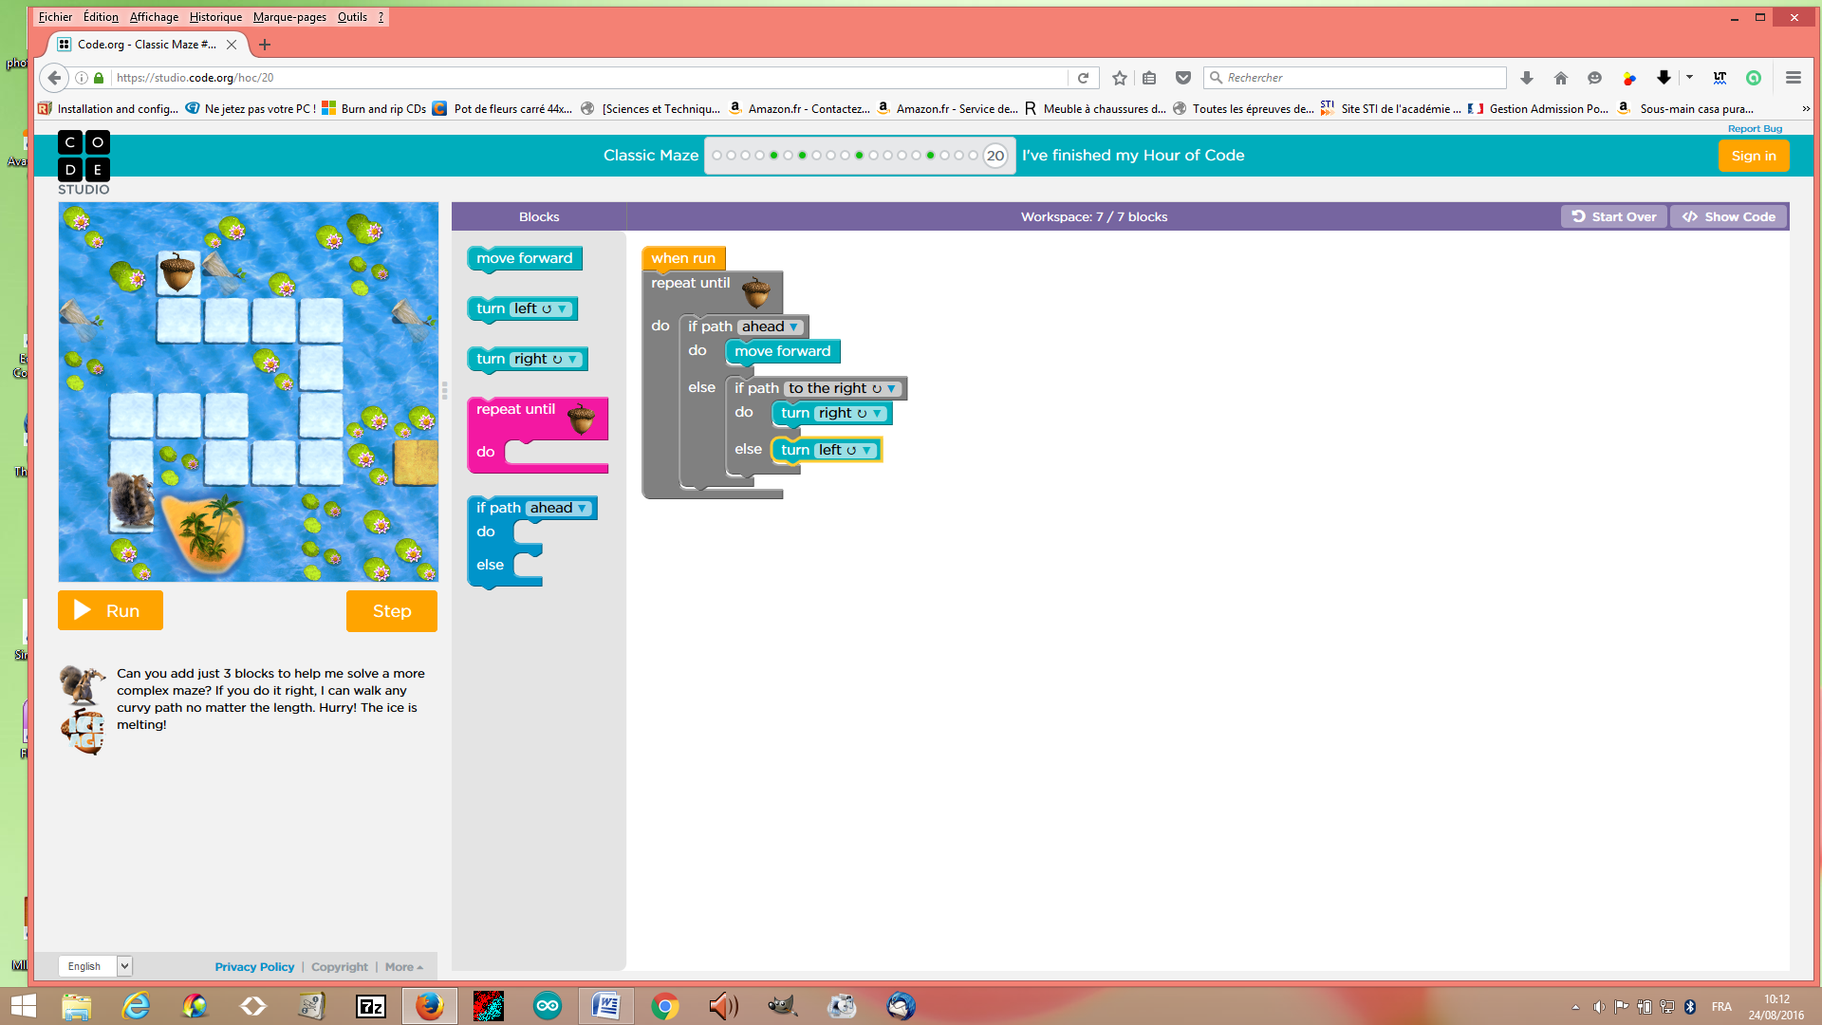

Name of the structure(s): …if and if/else statement

Explain the if- block and the if/else block:..Loop forever.

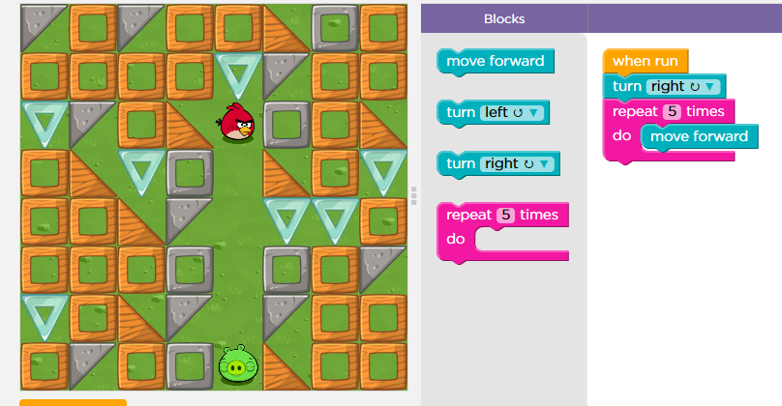
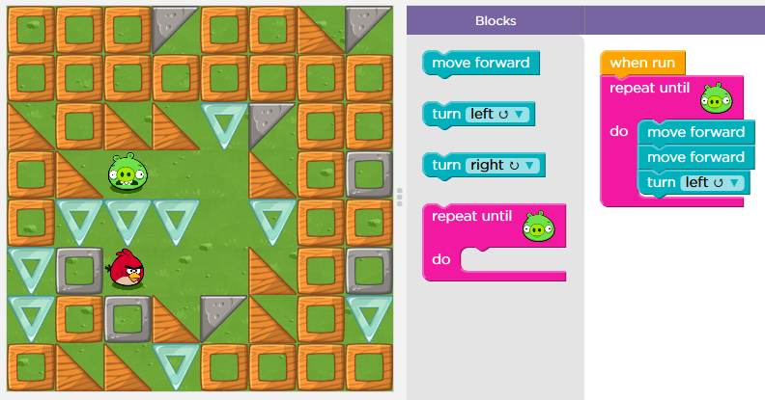

Name of the structure: .Repeat structure...
Name of the structure: ..Repeat until structure..

You can use two different ways to repeat the same command. Explain both ways:
One block is for repeat a defined time and the other block is for repeat until the destination.

Question 3

Explain what the zombie will do to get to the flower.
What statement can be used in your code?

It’s repeat until flower what can be used in my code.

Question 4

Click the file “blockly_crossword.htm” and complete the crossword.

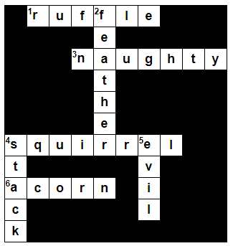

Write down your score: ….....100%........…

Save your answer sheet as “Test_L1_your name” in your groupe folder in LOL.

(Dossier MID_GR...).

