Answer sheet | MID Anglais-SI | Quick programming learn  Part 1 - Blockly

Question 1

VIDEO 1 HOUR OF CODE: INTRODUCTION

Who is the first person interviewed on the video?
The first person interviewed on the video is Bill Gates

What class was he in when he first learnt to program?
He was in 8ème

What is the name of the next man talking in the video?
The next man is Mark Zuckerberg

What is computer science?
It’s the computer (informatique), the programming, etc…

What is programming according to Drew?
Drew is the creator of Dropbox.

What kind of programming “language” will be used in this program?
We use Blockly for programming

What is the purpose of programming in this video?
In this video, the purpose of programming is the game, learning with a games

What is the workspace for?
The workspace is for put the blocks and attach theme

How do you “write” a command?
For write a command, put somewhere a blocks

What do you do when you want to delete a block?
Put in the bean

VIDEO 2 HOUR OF CODE: MARK

What are computers really good at?
At repeat the operation during a long times

What is a billion of times? Write answer in French.
Qu’est-ce qu’un milliard de fois ?

VIDEO 3 HOUR OF CODE: CHRIS

Who is Chris?
It’s a star of NBA

How do you get good at doing something?
On repeat and repeat…

What did he do when practicing his sport? Why do you think he did that?

When you practice a sport, you repeat a moves until succeed the move, the programming is same.

VIDEO 4 IF ELSE BLOCK

What is an if-else statement?
The if-else statement is the block who say if you can do the action, do that, if you can’t do the action, do an other action.

What is the difference with the if-block?
The if block say, if you can do the action, do that, while the if-else block to the previous, answer.

In the first lesson five programming structures where introduced: linear structure, repeat until structure, loop forever, repeat structure, if and if/else statement.

Question 2
Write, next to each picture, the name of the structure/structures used in the code.

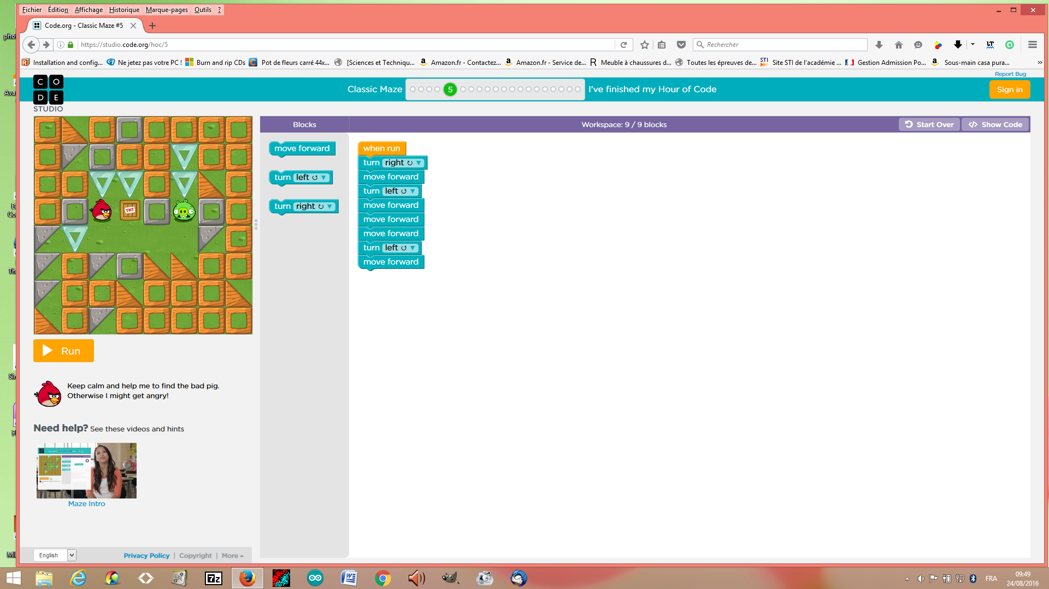

Name of the structure: linear structure

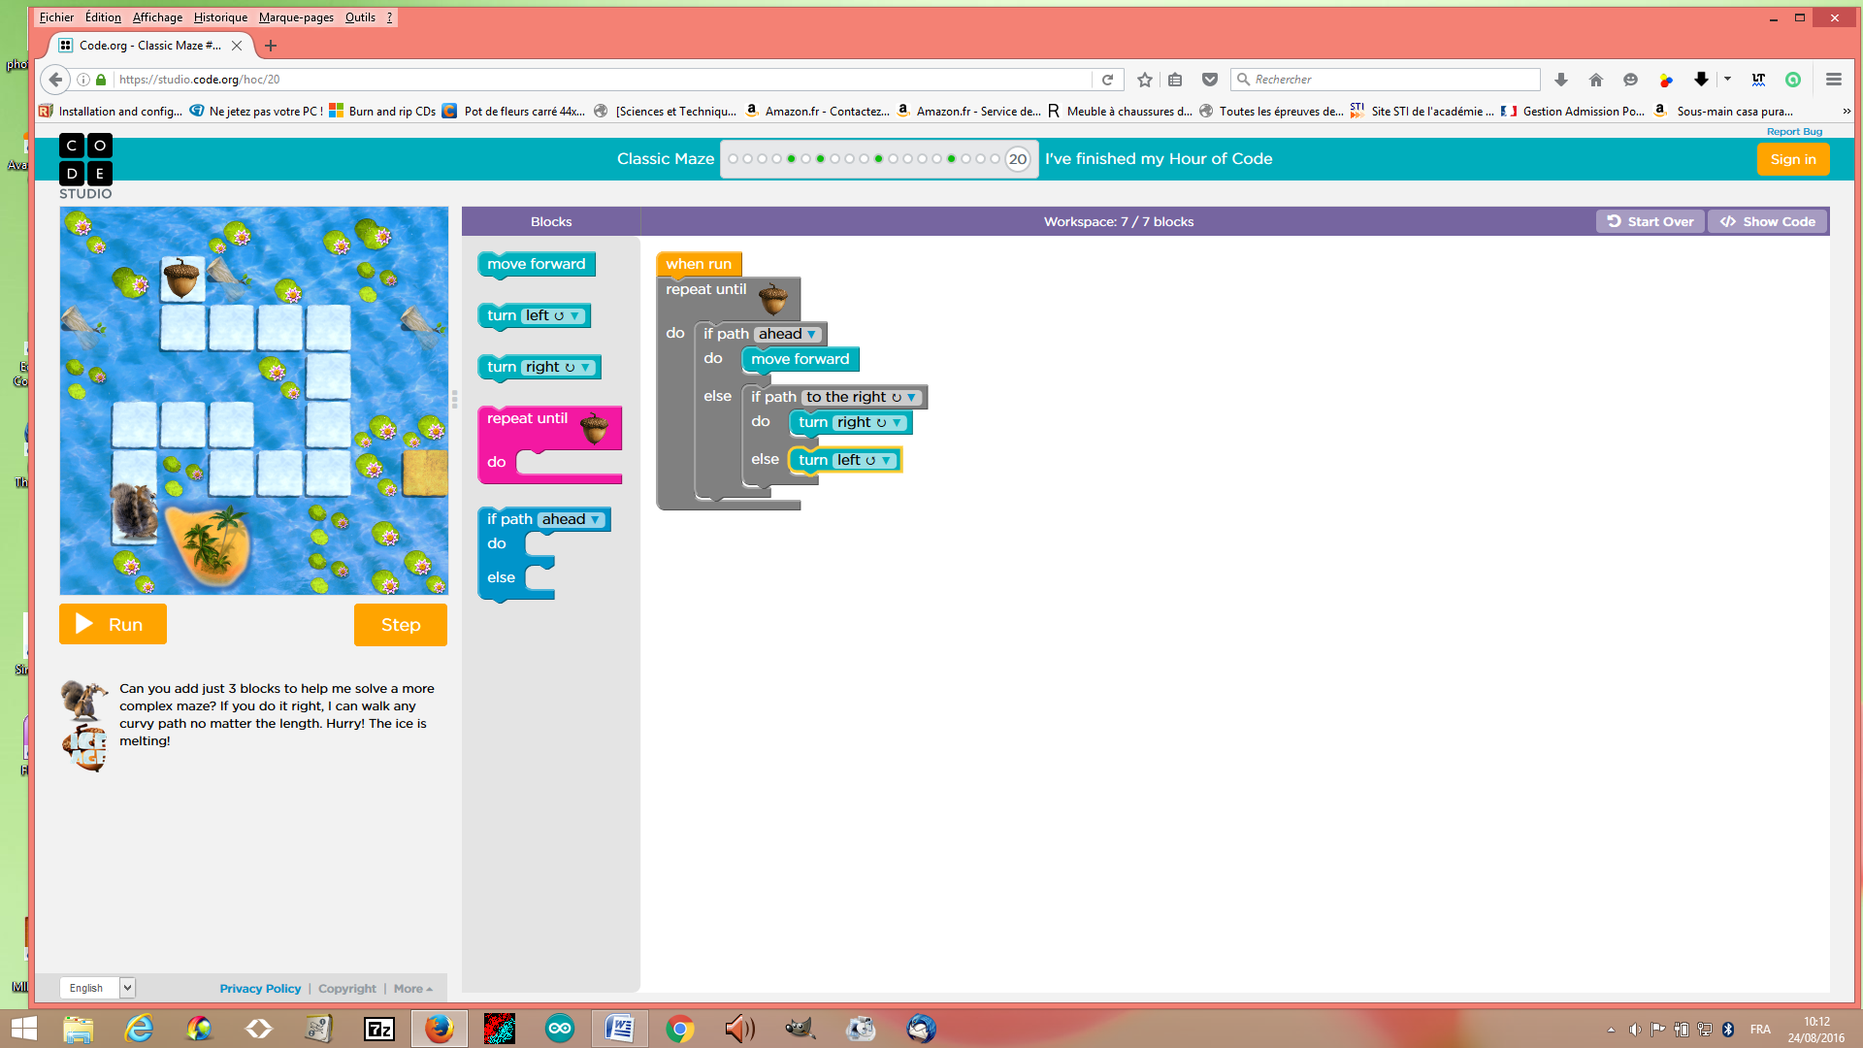

Name of the structure(s): if and if-else structure

Explain the if- block and the if/else block: The if block say, if you can do the action, do that,while the if-else block is the block who say if you can do the action, do that, if yon can’t do the action, do an other action.

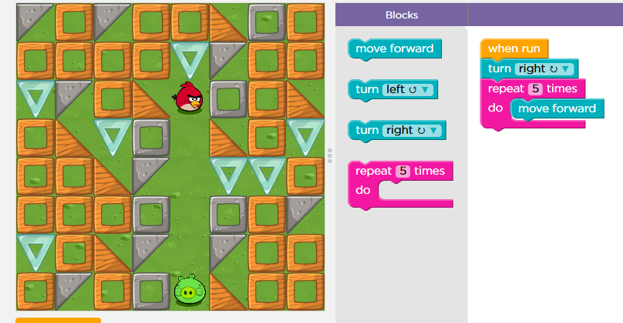
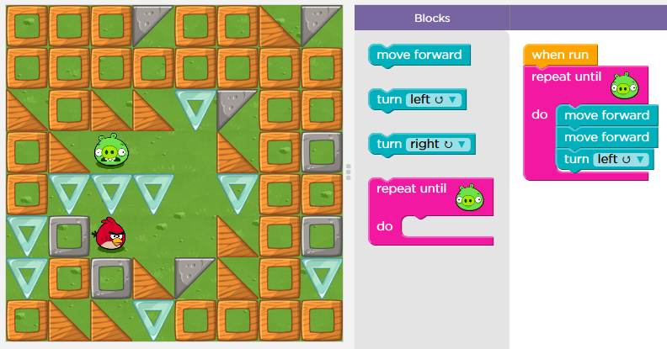

Name of the structure: repeat structure
Name of the structure: repeat until structure

You can use two different ways to repeat the same command. Explain both ways:
For repeat the same command, we can whrite linear structure or repeat structure

Question 3

Explain what the zombie will do to get to the flower.
What statement can be used in your code?

For the zombie eat the flower, needs to repeat until flower, turn right, move forward, turn left ans move forward.

Question 4

Click the file “blockly_crossword.htm” and complete the crossword.

Write down your score: 100%

Save your answer sheet as “Test_L1_your name” in your groupe folder in LOL.

(Dossier MID_GR...).

