Answer sheet | MID Anglais-SI | Quick programming learn  Part 1 - Blockly

Question 1

VIDEO 1 HOUR OF CODE: INTRODUCTION

Who is the first person interviewed on the video?

The first person interviewed is Bill Gates.

What class was he in when he first learnt to program?

He was on the 8 class.

What is the name of the next man talking in the video?

Her name is Mark Zuckenberg.

What is computer science?

It’s just learn how the computer works, and how it thinks.

What is programming according to Drew?

He thinks that it’s the closest thing we have to a superpower

What kind of programming “language” will be used in this program?

We will used blackly for this program.

What is the purpose of programming in this video?

The purpose is to learn basics programmation language.

What is the workspace for?

It’s on the right, it’s for built the program.

How do you “write” a command?

You put the block who you want on the work space.

What do you do when you want to delete a block?

You just need to remove it from the stack and drag it to the trashcan.

VIDEO 2 HOUR OF CODE: MARK

What are computers really good at?
They are really faster than men.

What is a billion of times? Write answer in French.
Billion = million

VIDEO 3 HOUR OF CODE: CHRIS

Who is Chris?

NBA All star
coded in college

How do you get good at doing something?

You get good at doing something when you repeat it a lot. With the time, you will be good.

What did he do when practicing his sport? Why do you think he did that?
When he did his sport, he repeat to make ten free throws in a row similary, and don’t leave the practise before to have done it.

VIDEO 4 IF ELSE BLOCK

What is an if-else statement?

It’s a decision between two things.

What is the difference with the if-block?

There is an other part, tell “else”, on the basic “if-block”.
So that mean that if the first block can’t believe, the second, “else” will happen.

Question 2
Write, next to each picture, the name of the structure/structures used in the code.

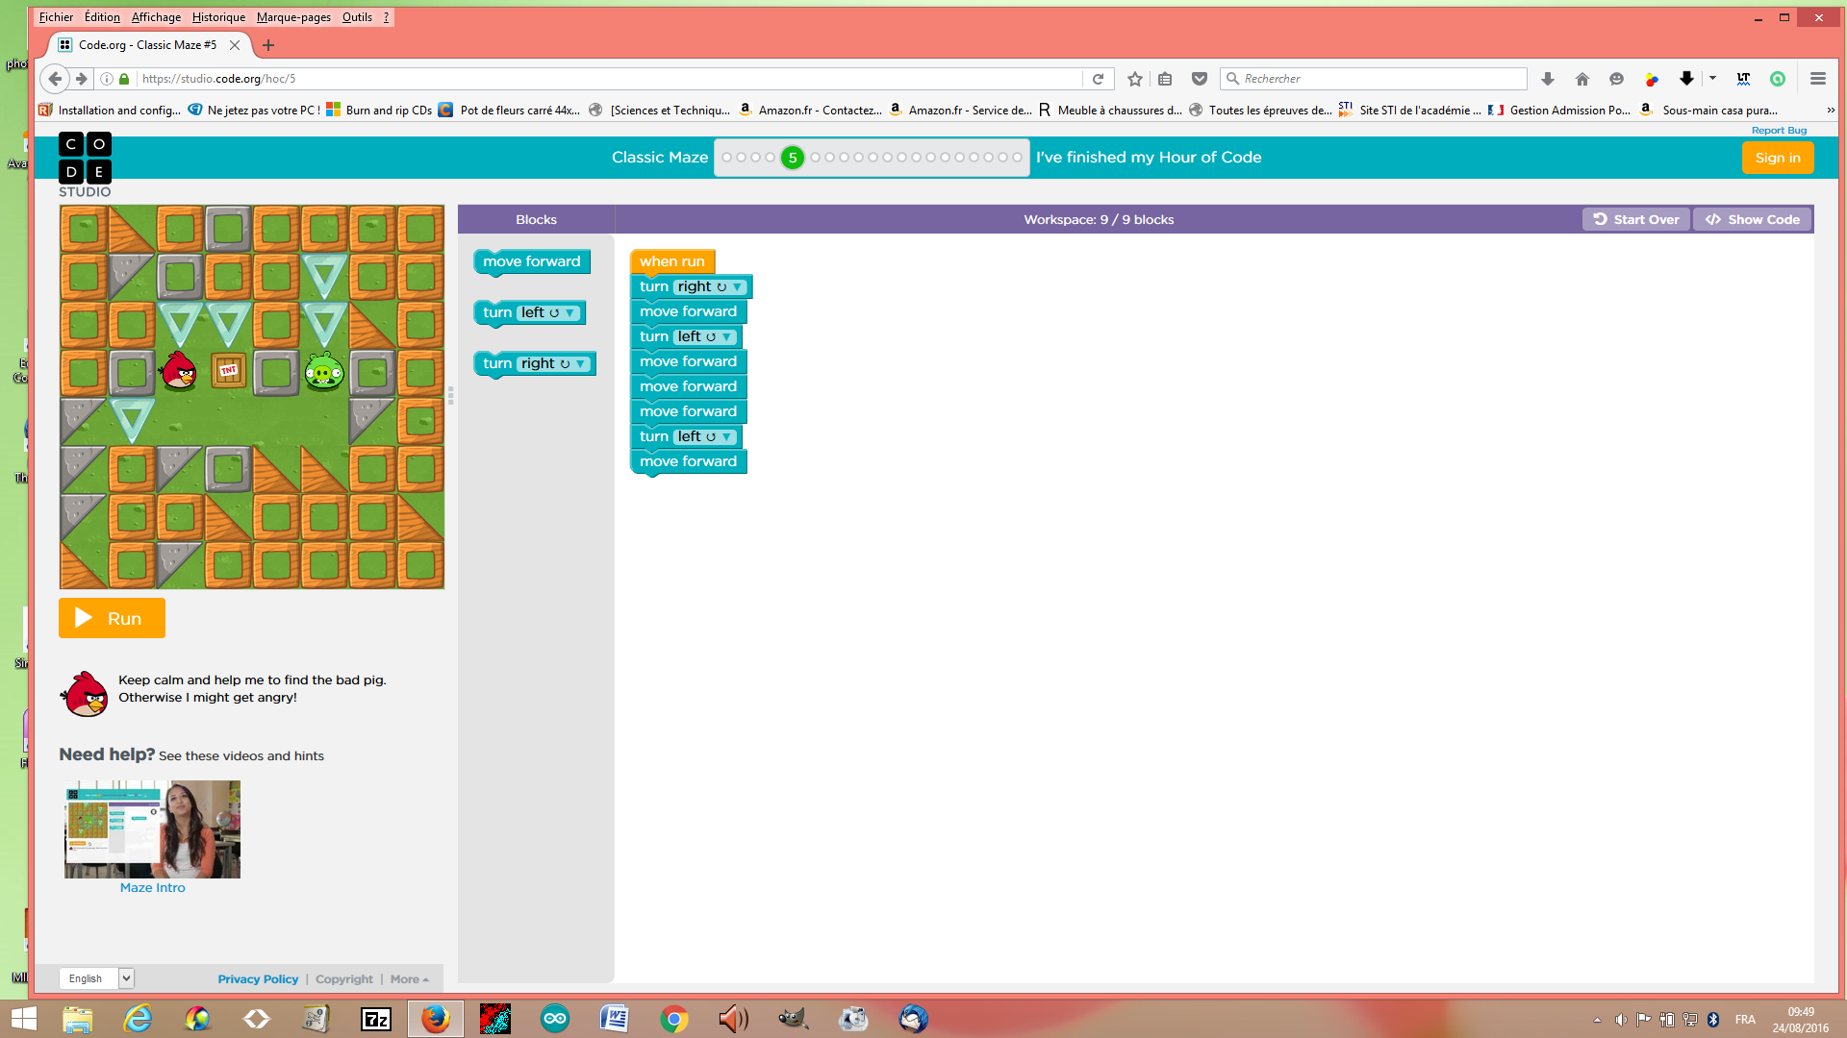

Name of the structure: ....
Linear structure

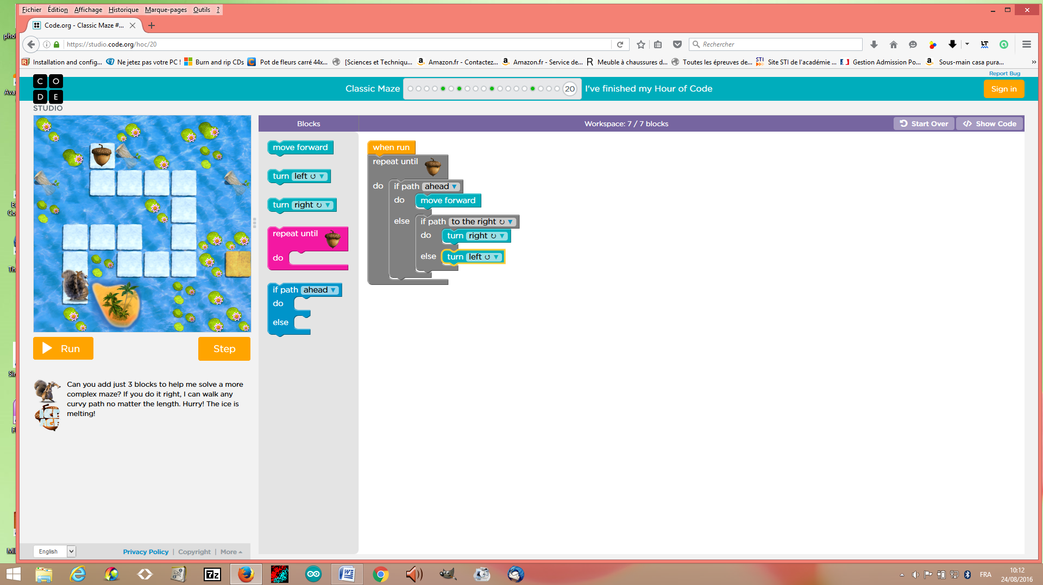

Name of the structure(s): if/else statement

Explain the if- block and the if/else block:…

if block is
else block

In the first lesson five programming structures where introduced: linear structure, repeat until structure, loop forever, repeat structure, if and if/else statement.

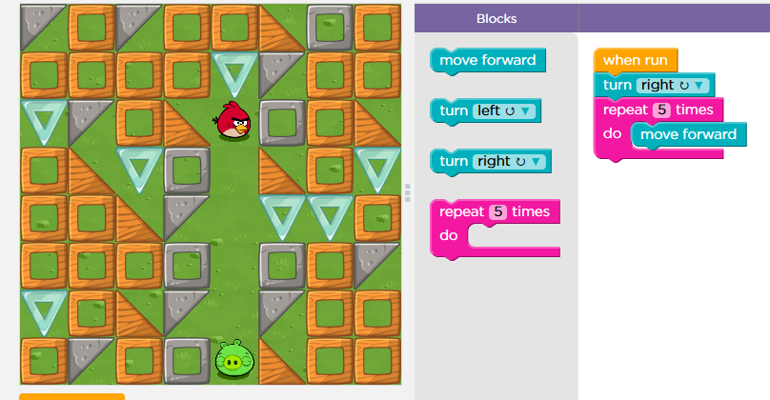
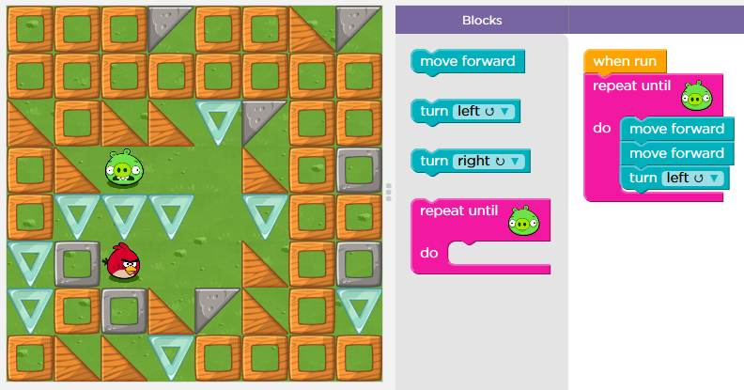

Name of the structure: repeat structure
Name of the structure: repeat until structure

You can use two different ways to repeat the same command. Explain both ways:

for repeat the same command, we can write linear structure or repeat structure

Question 3

Explain what the zombie will do to get to the flower.
What statement can be used in your code?

For the zombie eat the flower, needs to repeat until flower, turn right, move forward, turn left and move forward.

Question 4

Click the file “blockly_crossword.htm” and complete the crossword.

Write down your score: …................

Save your answer sheet as “Test_L1_your name” in your groupe folder in LOL.

(Dossier MID_GR...).

