
Still alive ! English food has not killed me and I'm back with lots of memories :D (If one of my classmate isn't as live as me, it's not my fault, I swear!) However, I would kill for a bed. And a pie.

While I think ! Something funny happened.We were at the National History Museum and I was with Amandine, Juliette and Roxane. We were looking for our fabulous, fantastic and not absolutely mad (*cough ironic*) teacher Mr.Temperau in Green Zone. We turn around the zone. Three time. Then we descended few stairs to get into the toilet, and lift up to the Blue Zone. We also tried to complete our travel book, but it was not a great success.
« Where is the skull ? In human history I guess. Where is human history ? … It' there ! Right ! Left ! Right ! Er... I fell...we are going in circles. » (Obviously, we have not tried more)
At the end, we abandoned the idea of finding our group. It's fascinating, dinosaurs ! It was not in the program of the visit, but to the point where we were, huh...
Did you know, for exemple, that T-Rex was so heavy and fast they could die from a fall when they run ? Exciting, hum ?


Other thing...bus travel are the best thing in the world. Yeah, is not convincing isn't it ? But, seriously, sleep in a bus, it's hopeless for me. Between this light in the emergency stairs and the noise of my classmates...infernal. Funny but infernal. When I'm tired, I get strange. You never saw me at 2 a.m. I was doing the ostrich in my pillow and marvel at service stations (and lights). I was tired, it's not my fault !
And the return...thak to the guy in my left diagonal, with is smartphone. Even without the sound, on a little screen and with Roxane on my knee (you're heavy, y'know), it was fun to see the Hobbit II !
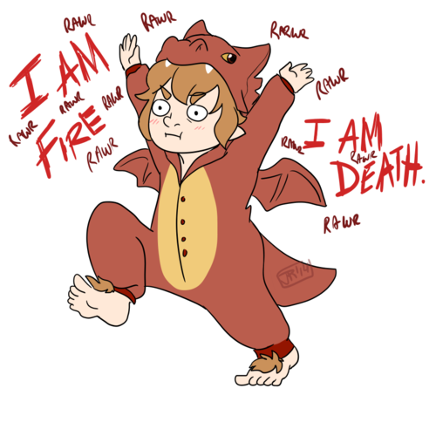
Sorry for all the people who think we are all crazy in France but dance in rythm of a french song is good for moral.

