My fisrt trip in England

Hi everybody ! I'm home and I loved my first trip in England. I had lots of funny moments and I am going to tell you. So, you set up and you read on.

First, let's start in Coventry in my host family with Léa. At 6:00 am, the lady took shower and the heater was in our room and it made a lot of noise. Arrggh ! And that every morning ! I felt angry and cross. Fortunately Léa was there to give me a smile.

My favourite day was the shopping day. All morning we went shopping. With Charlotte, we were walking in Oxford Street when suddenly we saw the hour. We ran on 1 km through people. It was so funny but we were breathless. People looked at us strangely.

In the bus ? I was having a stomache ache when Mathéo proposed me Smecta instead of Spasfon. I cracked up ! What an unforgettable moment !

And to finish, the evening on the ferry. On the boat there was a bar where there was a dance floor. In the evening everybody danced, we burst as crazy. We even danced the Macarena with the teachers. A memorable evening and the best !

Here is I really made a perferct trip, we really enjoyed ourselves and we discovered new things. One special thank to our teachers to have organized this trip. What an amazing experience.
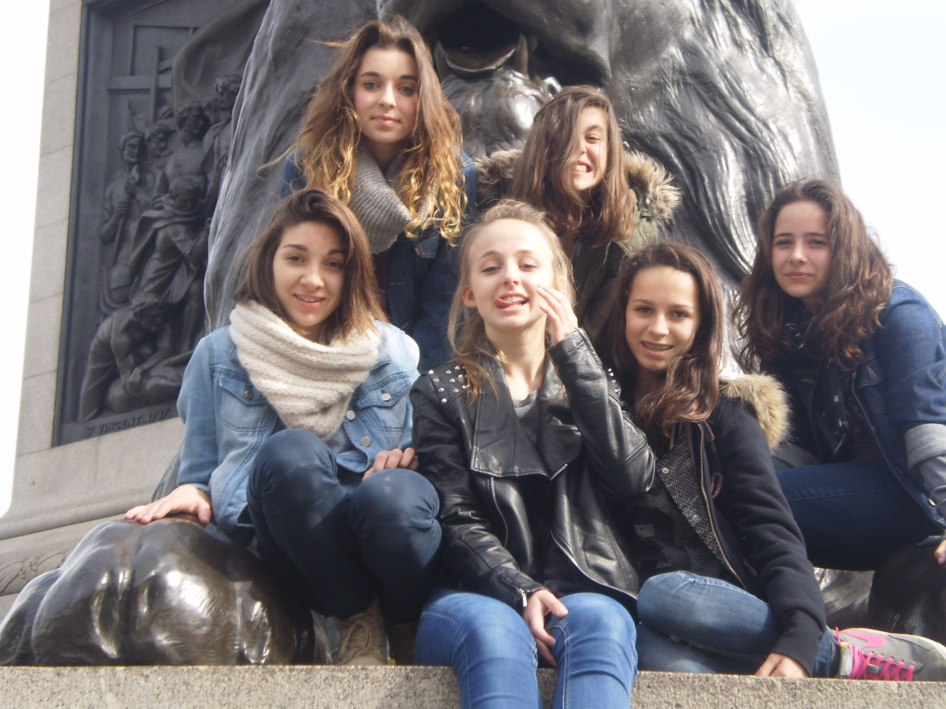
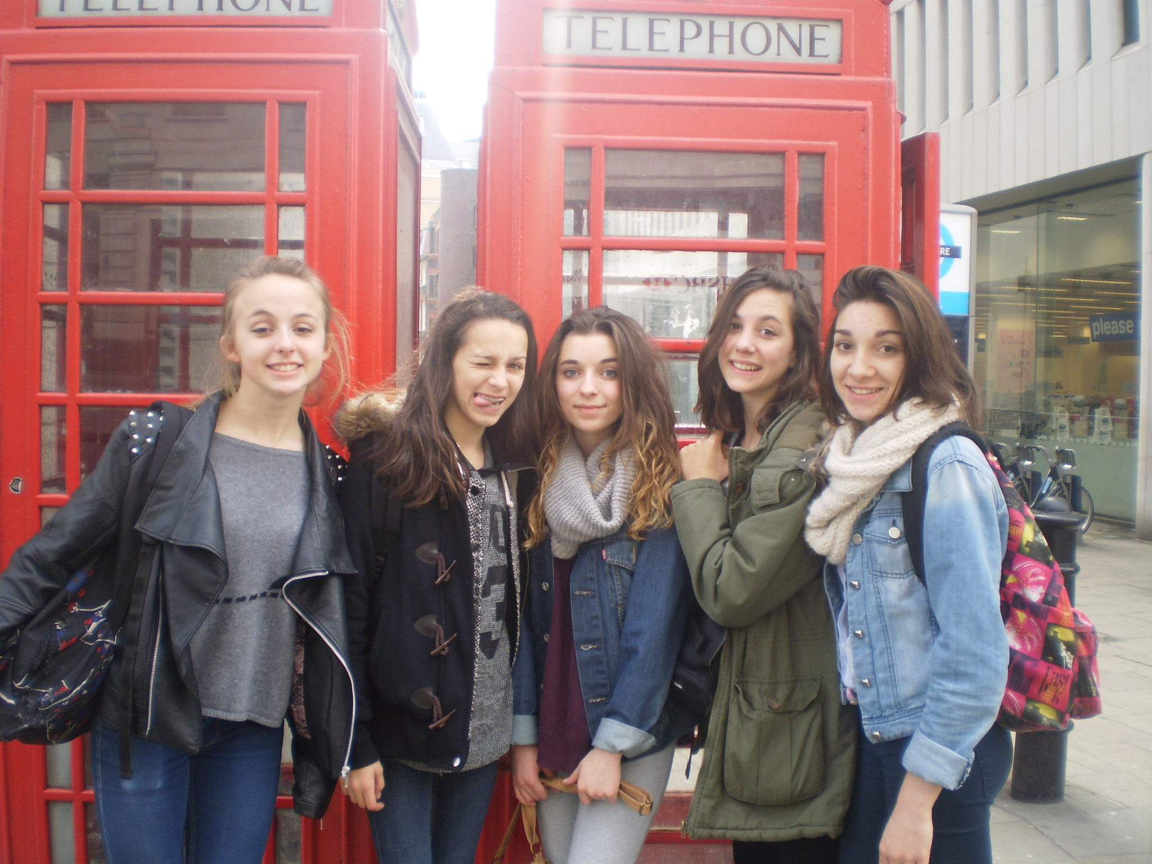
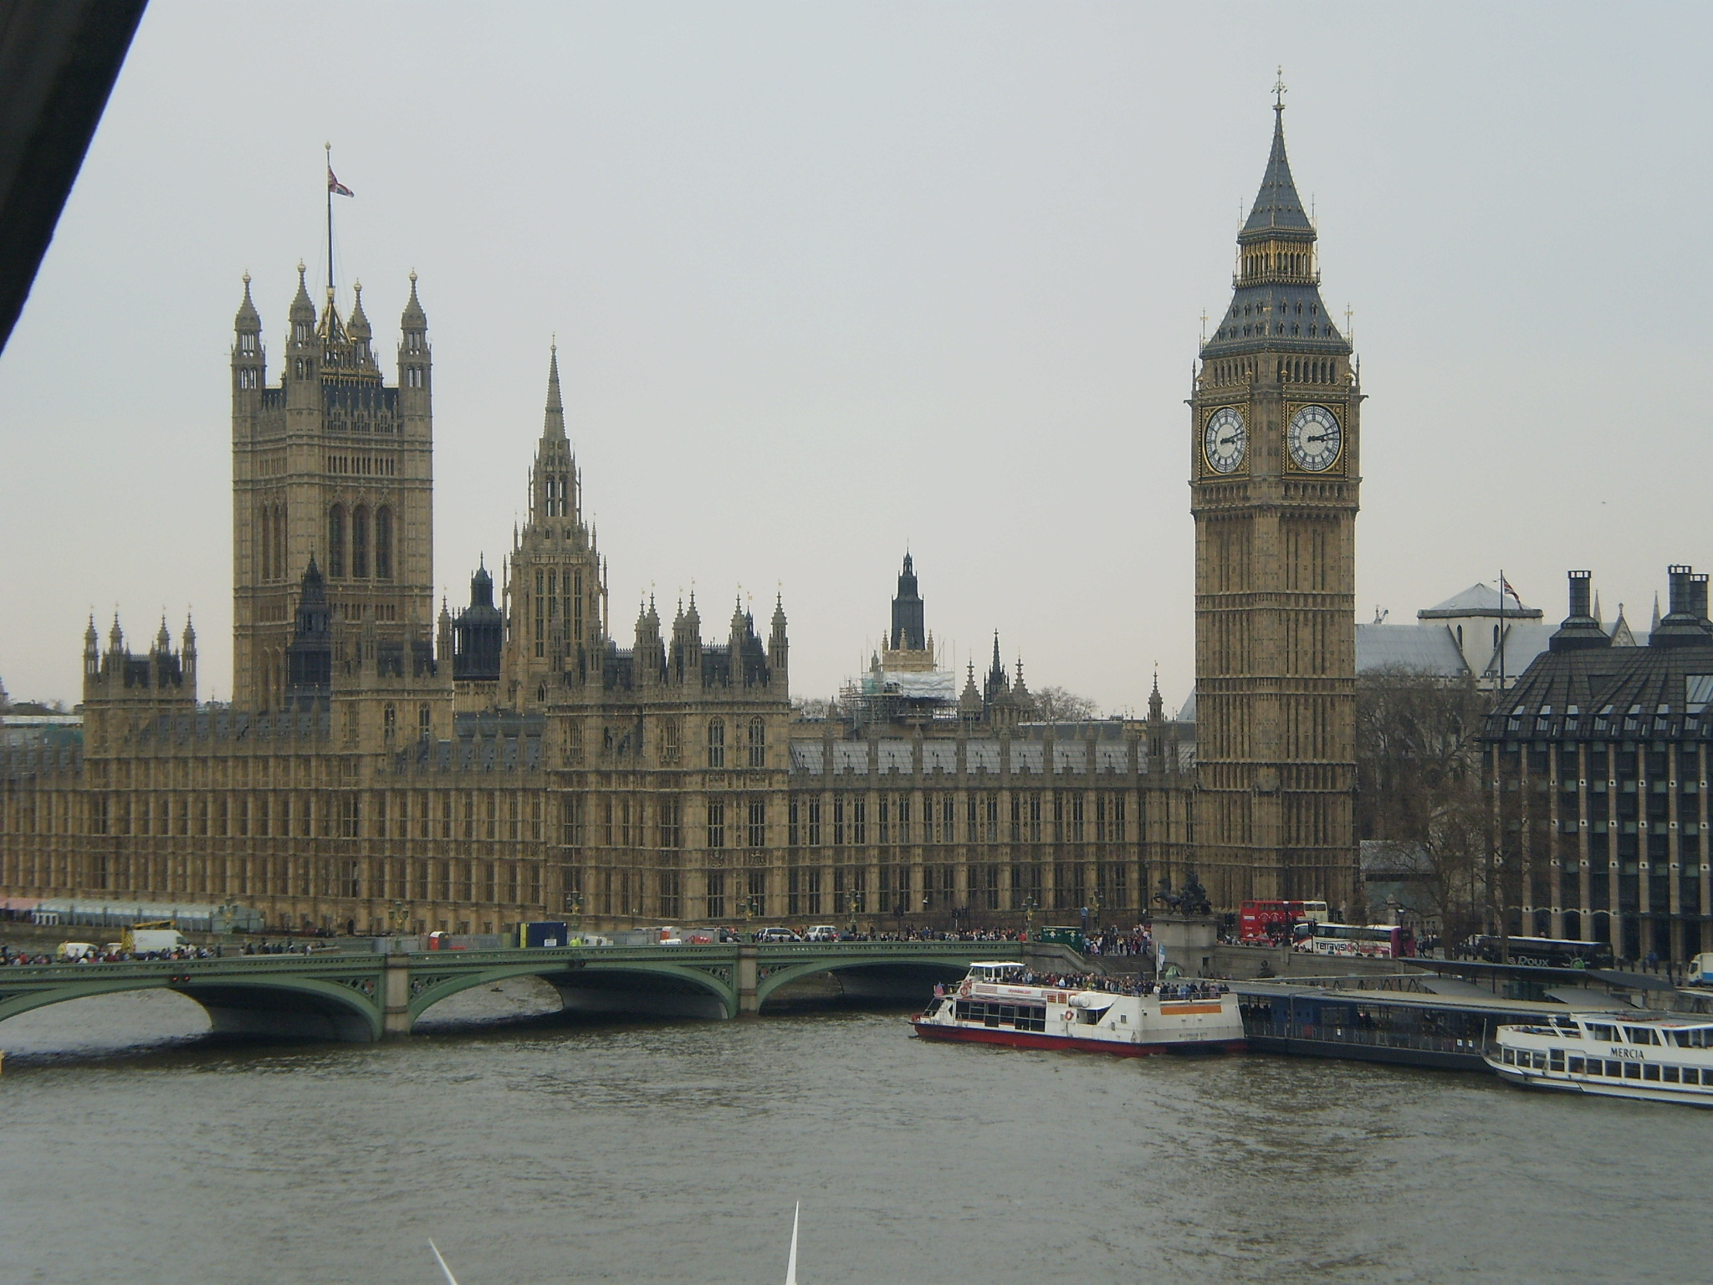
Good bye for a new article
xxxx <3 Mathilde

